Chapter 3: Ohms law

**Ohm law:**

**statement:**

Ohm's law states that “The voltage or potential difference between two points is directly proportional to the current or electricity passing through the resistance, and directly proportional to the resistance of the circuit.”

Formula: v=IR

V= voltage

I= current

R= resistance

Power

Formula: p(t) = v(t)i(t)

**Active element:** supplies energy (like batteries, generators)

**Passive element:** absorbs energy (like resistor, capacitor and inductor)

***The end***

***Chapter 4***

***Node:*** In engineering, a node is any region on a circuit between two circuit elements. In circuit diagrams, connections are ideal wires with zero resistance, so a node consists of the entire section of wire between elements, not just a single point.

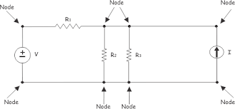

***Kirchhoff Law:***

***Important terms related:***

***Node:*** *A point where at least two circuit elements join*

***Loop:*** *A path in which starting node and ending node are same*

***Note:*** *Another name for loop is* ***mesh****. Be careful: Every corner point is NOT necessarily*

*a nod.*

*Identify all nodes, corner points and loops in this circuit*

***KCL - Statement 1:***

*Algebraic sum of currents in a node at a given time instant is equal to zero.*

***KCL - Statement 2:***

*The sum of currents entering a node, at a given time instant, equals the sum of*

*current leaving that node.*

***KVL - Statement 1:***

*The algebraic sum of voltages in a loop at a given time instant is zero*

***KVL - Statement 2:***

*In a loop at a given time instant, the sum of voltage rise is equal to sum of*

*voltage drops.*